2014 “Hops for Habitat” Art Exhibit and Sale
At Hoptron Brewtique

CALL FOR ARTWORK

Background:
Marine habitat, namely eelgrass, is of high importance to our local aquatic ecosystem. Eelgrass meadows provide spawning, nursery, and foraging grounds for many of our valuable fish and shellfish species and for this reason need to be protected and restored where possible. In recent decades, eelgrass beds have been threatened by numerous water quality issues and physical disruptions. To combat eelgrass habitat loss, a great deal of effort is being put towards the study and restoration of this species by Cornell Cooperative Extension’s Marine Program. To help raise community awareness, we are seeking artist responses to this issue and would like to see works inspired by underwater habitat. Reflections of the value of our local marine environment may be presented in any medium and will be displayed, and listed for sale, at Hoptron Brewtique in Patchogue, NY in an exhibition that will take place from September 27-November 2, 2014.
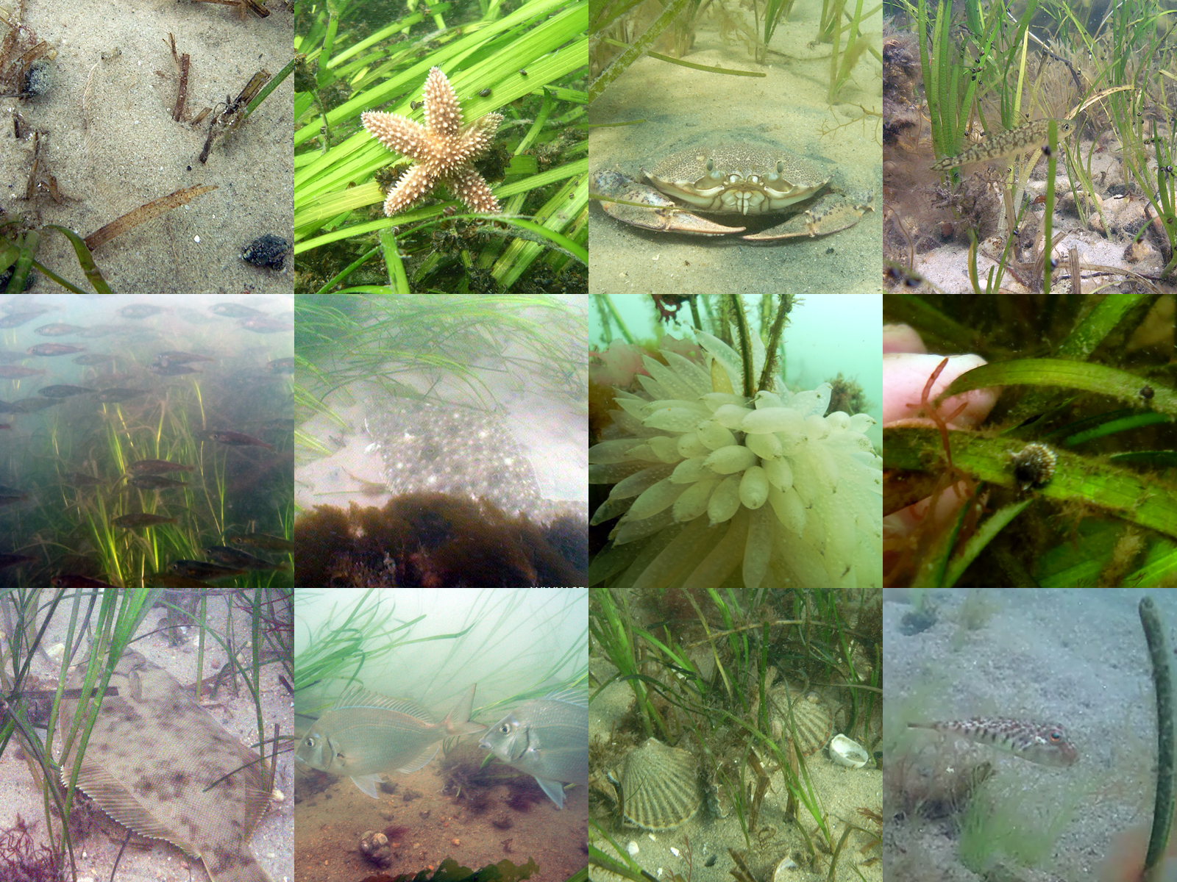
The above photos were taken by Cornell Cooperative Extension’s dive team at natural or restored eelgrass beds.
More photos and information can be found at www.seagrassli.org

Artwork Requirements:
We are seeking responses from local (Long Island-based) artists. Each artist may submit up to three works for consideration by the selection committee. Artwork of any medium may be submitted but must feature, or be inspired by, eelgrass meadows and the many fin and shellfish species that reside in and utilize this habitat.
For inspiration, we suggest visiting seagrassli.org and browsing the many underwater photos taken by CCE’s dive team. Art must not exceed 36” in width, or exceed 50lbs and must be ready to hang. 3-D works must be self-supporting or have an accompanying stand.

Timeline:
September 14, 2014: All submissions must be delivered to Hoptron Brewtique
September 19, 2014: Artists will be notified regarding submission selection
September 26, 2014: Artists must claim work not selected for exhibit by this date
September 27, 2014: Opening Reception 6-9pm at Hoptron Brewtique
September 27-November 2, 2014: Exhibit on display
November 9, 2014: Artists must claim unsold works by this date

Sales:
All work selected for display will be listed for sale. Prices for each work should be identified on entry form. Proceeds will be split 50/50 between the artist and Cornell Cooperative Extension to benefit the Marine Meadows Program.

Entry Forms:
Entry forms must accompany all submissions. Forms are available at www.marinemeadows.com and at Hoptron Brewtique.

Inquiries can be directed to Kimberly Barbour at 631-461-5294 or kp237@cornell.edu

